https://aloofness54.medium.com/fix-google-seq2seq-installation-errors-4a1155b13f73

fix bug “no module named bin.train”:
https://stackoverflow.com/questions/56207920/how-to-add-the-path-to-pythonpath-in-google-colab
! echo $PYTHONPATH
import os
os.environ['PYTHONPATH'] += ":/content/seq2seq"
! echo $PYTHONPATH

==========
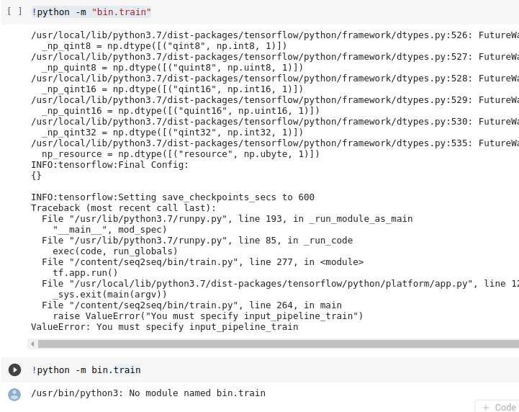
=================================

install seq2seq on google colab:
https://stackoverflow.com/questions/50513493/install-seq2seq-on-google-colaboratory

===================================
very important to understand “python -m”
https://snarky.ca/why-you-should-use-python-m-pip/

most close to our error:
https://stackoverflow.com/questions/66808336/how-to-permanently-install-a-library-in-colab

================
On colab
current version of tensorflow : 2.4.1
run “ !pip install tensorflow==1.13.1”
Then, check version of tensorflow again, it’s still 2.4.1

Solution: run “!pip3 install tensorflow==1.13.1”

===================
On colab
When installing seq2seq:
There is a big difference between running “!pip install -e” and “!pip3 install -e”
This command comes from the link https://google.github.io/seq2seq/getting_started/

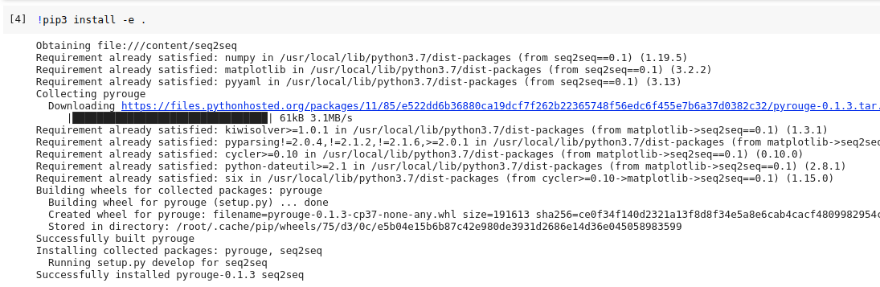

If we run “!pip3 install -e”
Then when we run “!python -m bin.train”, the result is :

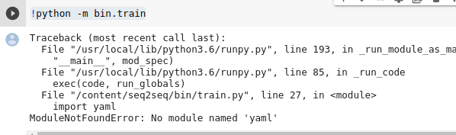

There is also a big difference between running “!python” and “!python3”

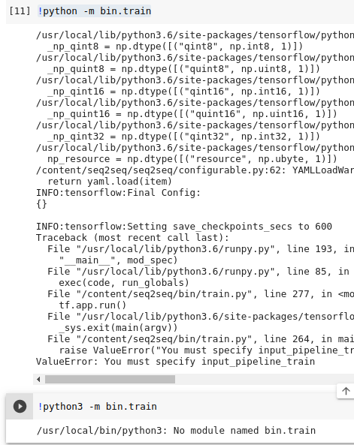

There is a big difference when running “!python -m bin.train” when we at different location
-When we are inside the folder “seq2seq” (the folder for installing seq2seq, taking from https://github.com/google/seq2seq)

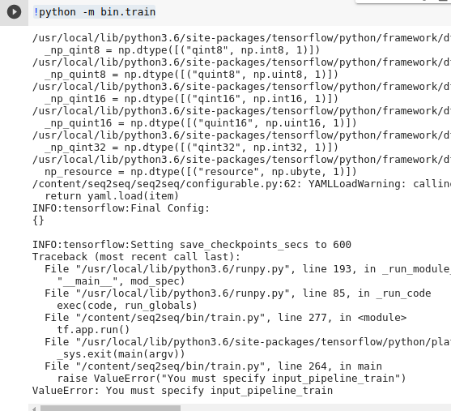

When we are at /content :

